Wildlife Strikes Notes

# Notes about the data

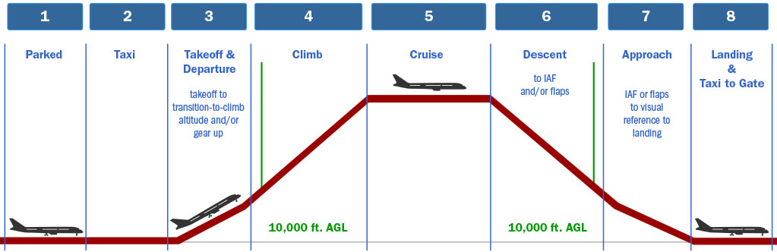

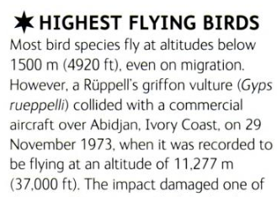[Animal](https://www.google.com/books/edition/_/T3FEKopUFkUC?hl=en&gbpv=1&pg=PA124) Records by Mark Carwardine

Planes [cruise](https://www.popsci.com/technology/how-high-do-planes-fly/) at 35,000 ft

Wildlife hierarchy:

1. Category (most general)
2. Species order
3. Species group
4. Species name and ID (most specific)

[Wildlife Management | Federal Aviation Administration (faa.gov)](https://www.faa.gov/airports/airport_safety/wildlife/management)

# Questions about the data

## Descriptives

1. How many total strikes were there?
   1. How many strikes by location?
   2. How many strikes by animal?
   3. Distribution of time
   4. Distance away
   5. Feet above
   6. Top 5 airports

## Correlations

1. When and # of strikes, category
   1. Time of day
   2. Phase of takeoff
2. Location and # of strikes, category
   1. Airport
   2. State
3. Animal and # of strikes, category
   1. Category
   2. Species
   3. Species order?
4. Animals, time of day, and # of strikes, category
   1. Ex. Bats at night, birds during the day?
5. Cost (days, $) versus category, by location
6. Strike vs location vs category?

# Observations:

* Top 4 states are: California, Texas, Florida, and New York (respectively)
* Birds make up a very significant proportion of strikes (almost 96%)
* Most strikes occurred during the day
* Most strikes occurred on runway (takeoff and landing roll) and close to the ground (departure/arrival)
* Almost all strikes were within 10 miles of the airport
* Most strikes were below 4,000 ft elevation
* After birds, terr mam make up most strikes. Bats have their highest representation at night.
* Cost by state:
  + Highest total NY
  + Highest Average AL
* Either high cost or high delay, not much correlation
* Florida had 17 reptile strikes, vs 0-2 for all other states
  + Mostly turtles and a few alligators
  + During landing/takeoff
  + Bats and mammals matched birds

# Story/narrative:

* Save the turtles?!?
* Airplane safety: The most dangerous states for a bird to live